**Assignment -1**

**THE CASE OF 50 STARTUPS**

|  |  |
| --- | --- |
| Student Name | AARTHI B G |
| Student Roll Number | 921319104001 |

1. **R&D Spending**

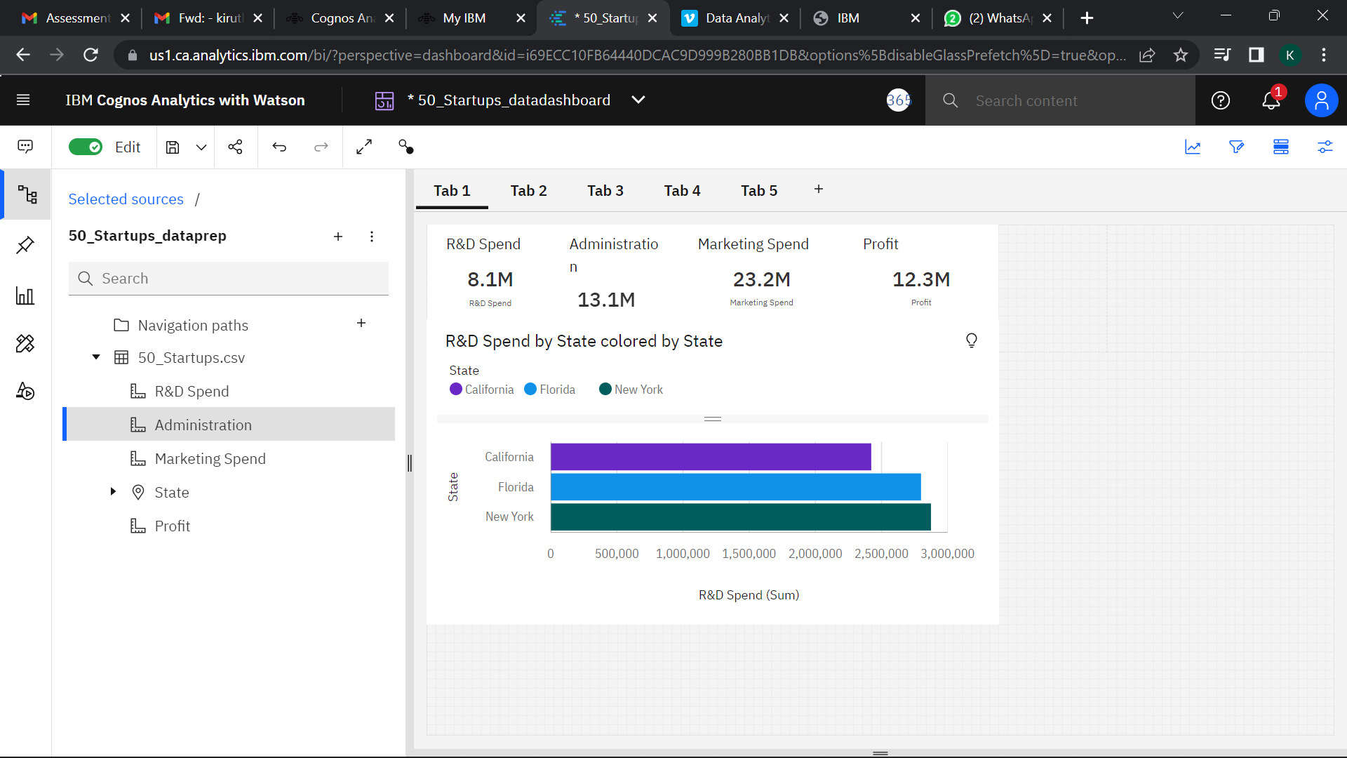

1. **Administration Spending**

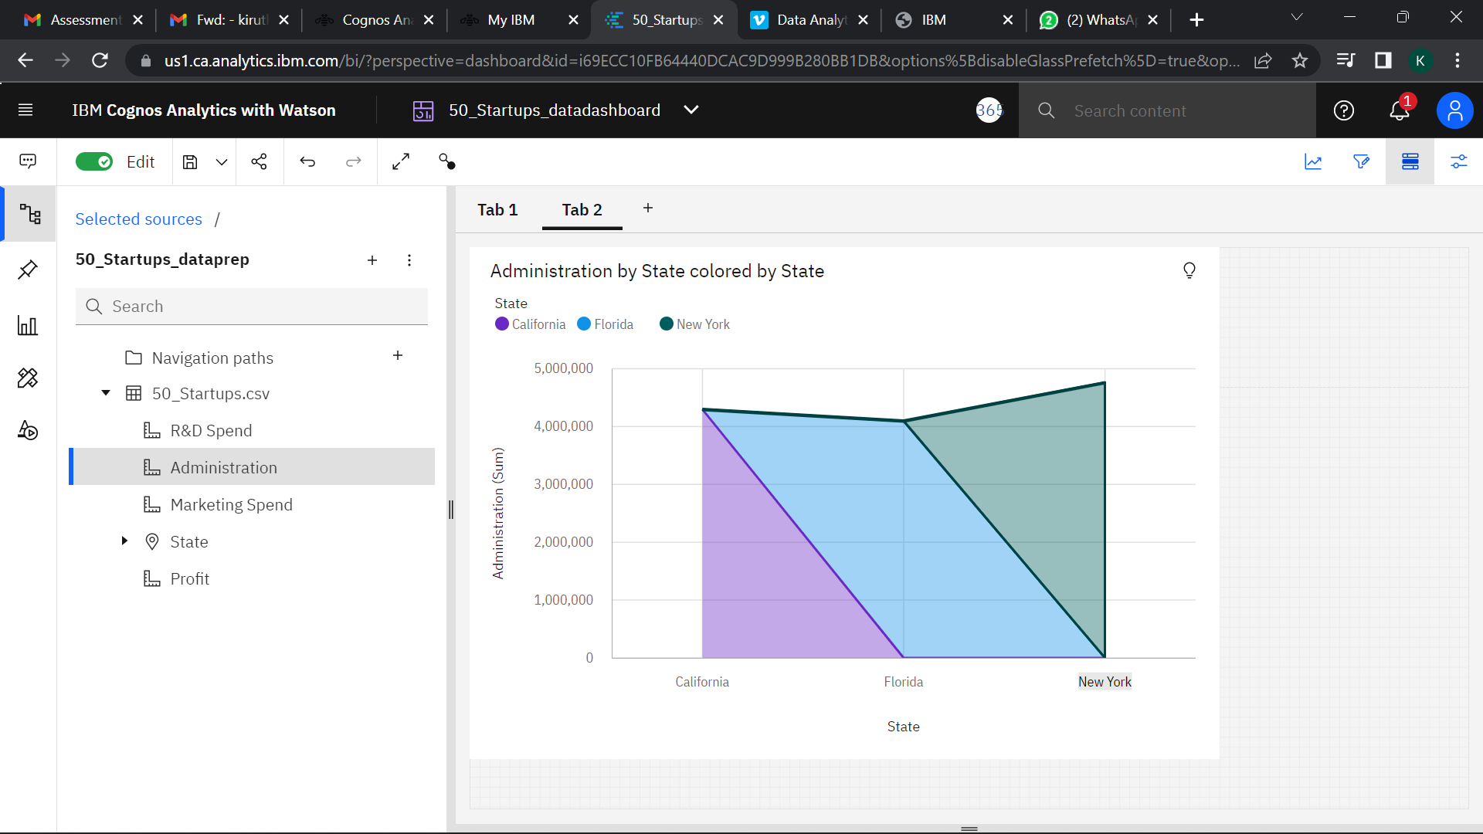

1. **Marketing Spending**

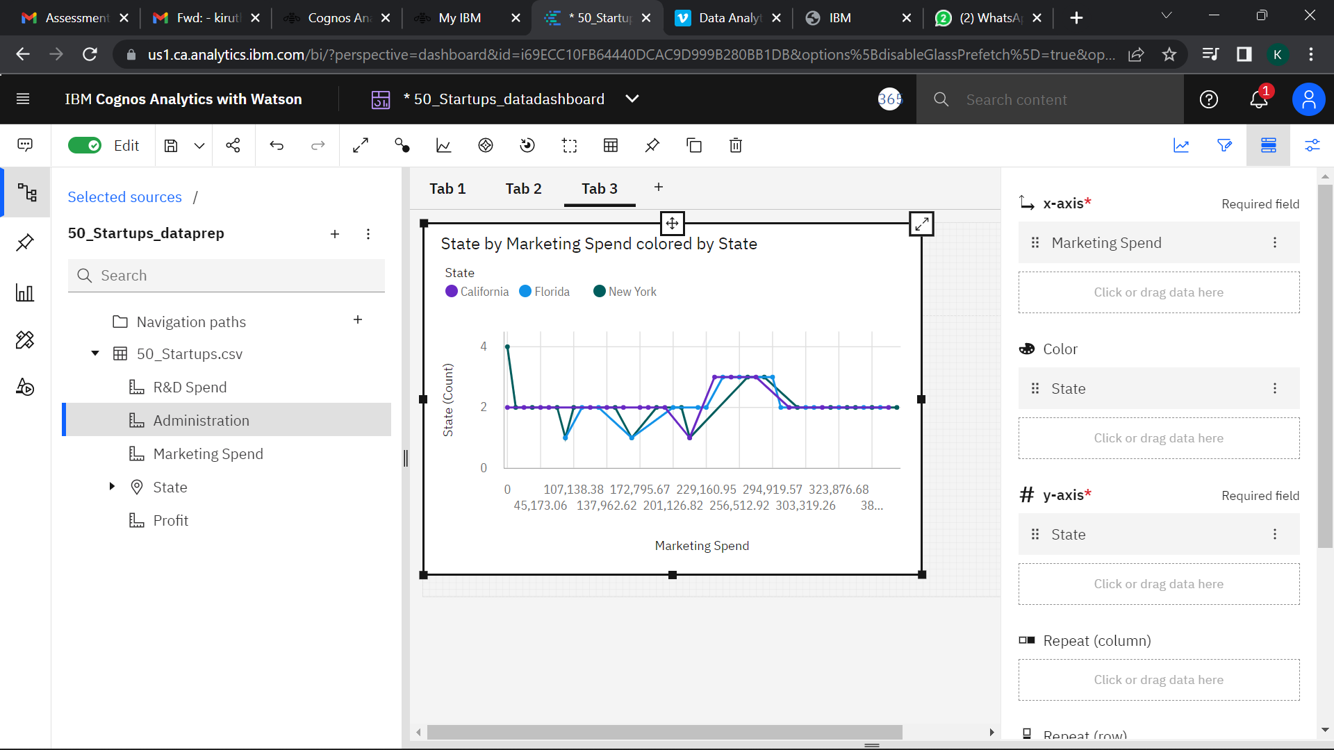

1. **State**

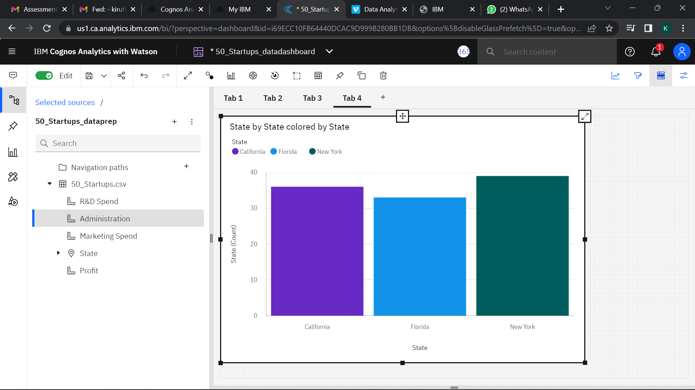

1. **Profit**

